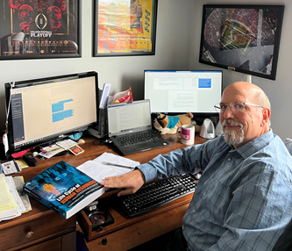  HR Certification Prep Courses  Choose the study options that meets your needs!  Option 1 – HRCI-PHR/SPHR  Live Sessions (via Zoom) Cost $700  Eight classes meet via Zoom every Tue from 6-9 PM. PHR/SPHR classes start on Jan 13th and run for 8 weeks. Includes PPTs to study from, glossary of terms, practices quizzes, resource book that comes with more practice questions. Sessions are also pre-recorded in case you miss one or want to review.  Option 2 – SHRM-CP/SCP –  Live Courses (via Zoom) Cost $700  Eight classes meet via Zoom every Thurs from 6-9 PM. CP/SCP classes start on Jan 15th and run for 8 weeks. Includes PPTs to study from, glossary of terms, practices quizzes, resource book that comes with more practice questions. Sessions are also pre-recorded in case you miss one or want to review.  Option 3 – SHRM-CP/SCP or HRCI PHR/SPHR  Self-Study – Cost $600  48 Lessons - with 20–30-minute lectures, PPTs to study from, glossary of terms, practices quizzes with over 250 questions, resource book that comes with more practice questions and access to a coach that cares about YOU.  Corporate and Group Rates Available  Please reach out to me for information on corporate and/or group rate options.  What Others Have Said!  “I just wanted to thank you for all of your support and guidance in preparing me to achieve this milestone career. 🙏🏽 I could never repay you enough, but I pray that God gives you the desires of your heart. Thank you so much!”  “Hey Tom! I took the SHRM- SCP exam today and passed 😊! Thank you for your prep course it was a tremendous help. Now I am certified! Woohoo!”  “I am proud to say that with the help of my friend Thomas Mobley, SHRM-SCP, SPHR and his Online Prep course I successfully passed my exam and am a SHRM Certified.”  .
  Prepare for HR Certification the way that best meets your needs!
  ____
  Class participants have an 88% pass rate on their exams
  ____
  * Payment plans available * If you don’t pass your next class is FREE * Life gets in the way and you don’t take your test, cost to retack a class with us is $100
  ____
  Register at
  MobleyHR.com
  ____
  Thomas Mobley, SHRM-SCP, SPHR has over 30 years’ experience leading study sessions, has worked in HR and taught HR at the college level for over 30 years
  Mobley HR Consulting
  To register, simply email Tom.MobleyHR@gmail.com or go to MobleyHR.com
  513.703.9699

