Recovering Citizens: Resourceful, Resilient, and Ready to Work
Over 23 million Americans are in recovery from substance use disorder (SUD), demonstrating extraordinary resilience, determination, and strength. They are our friends, neighbors, family members, and colleagues—and they bring unique, financially remunerative value to the workplace. Recovery Friendly Hamilton County (RFHC) exists to help employers create supportive environments where recovery can thrive.




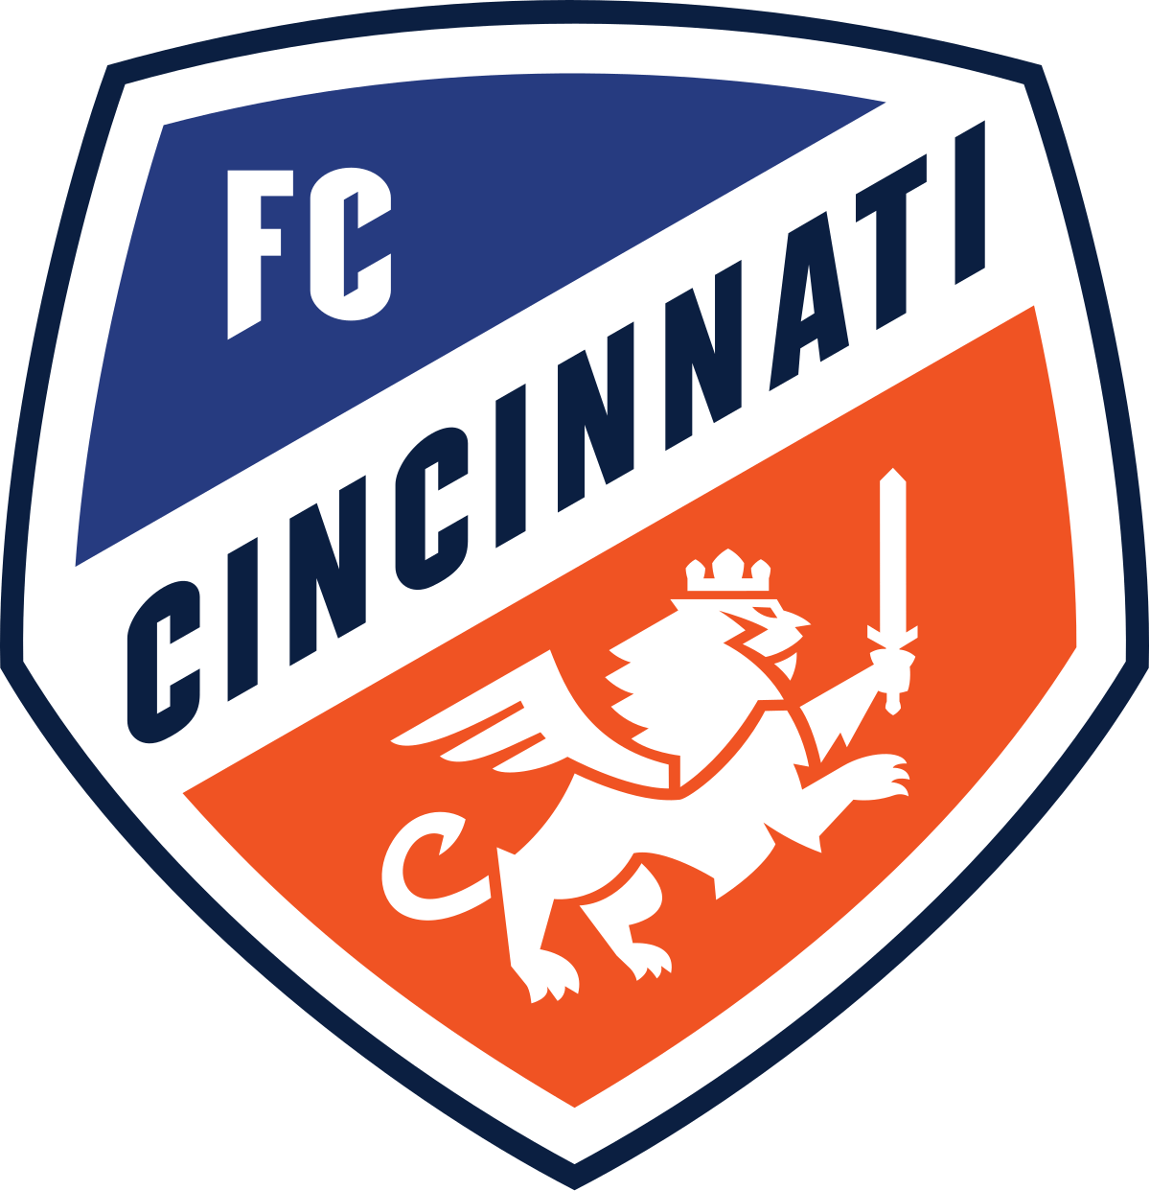


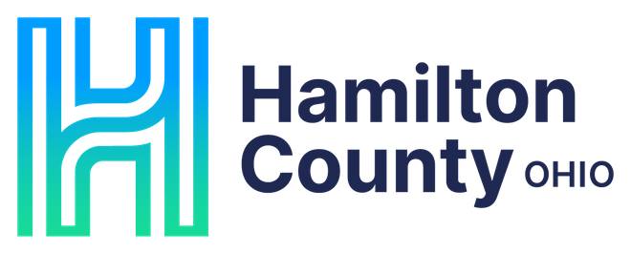




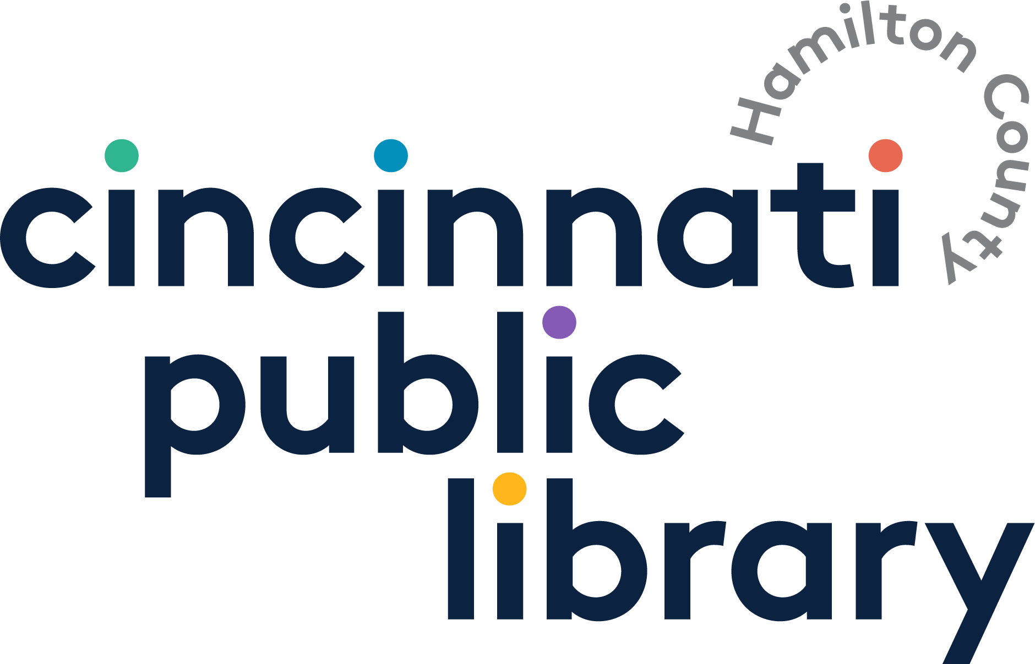
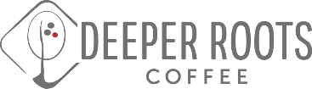




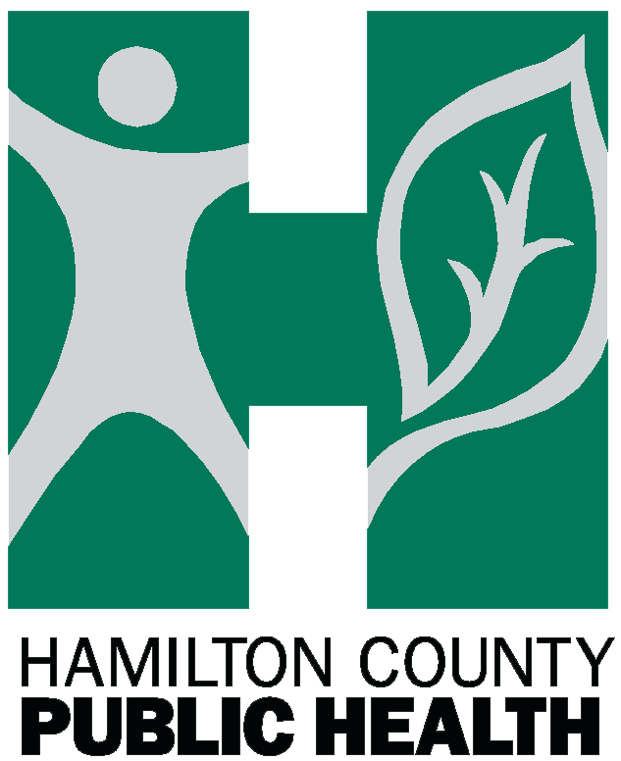
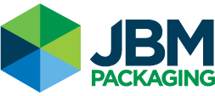
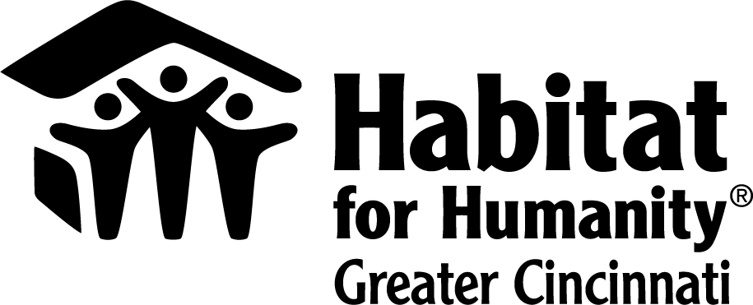
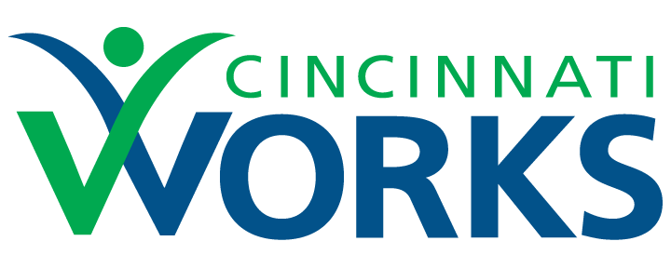

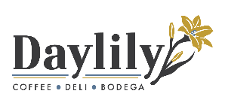


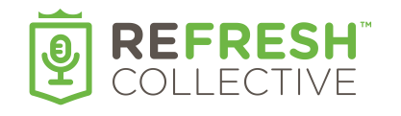
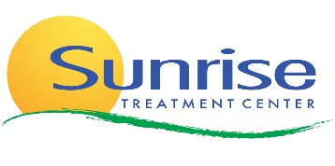

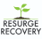
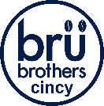

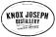
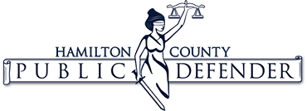
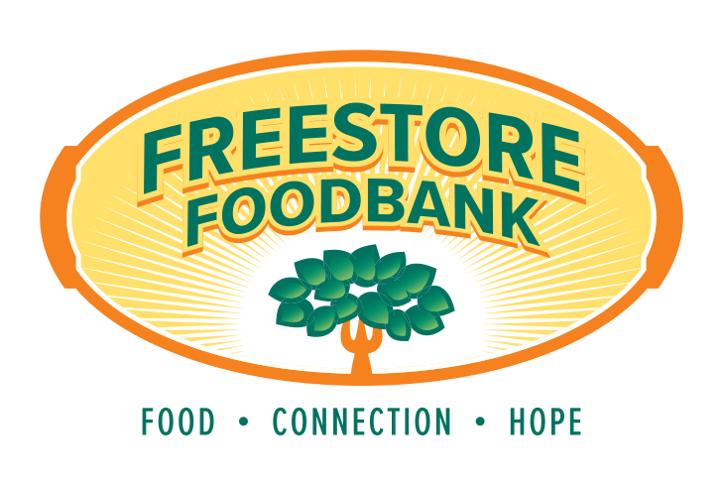

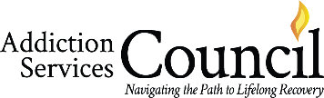

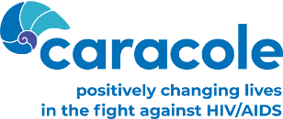
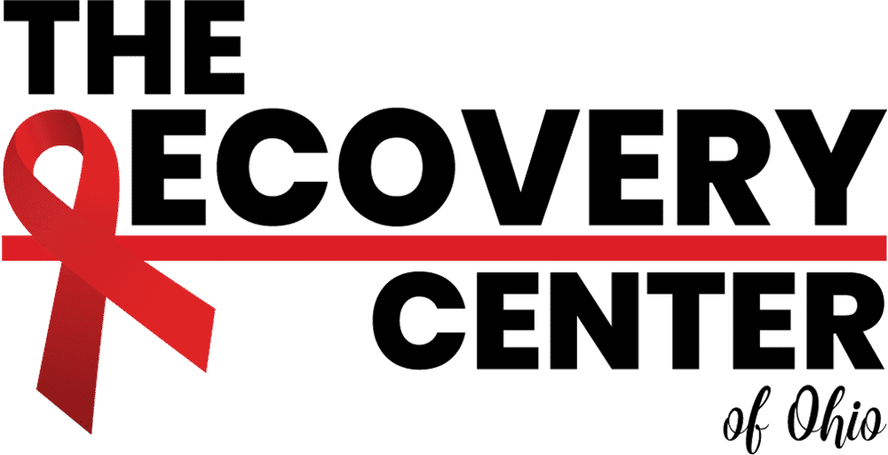
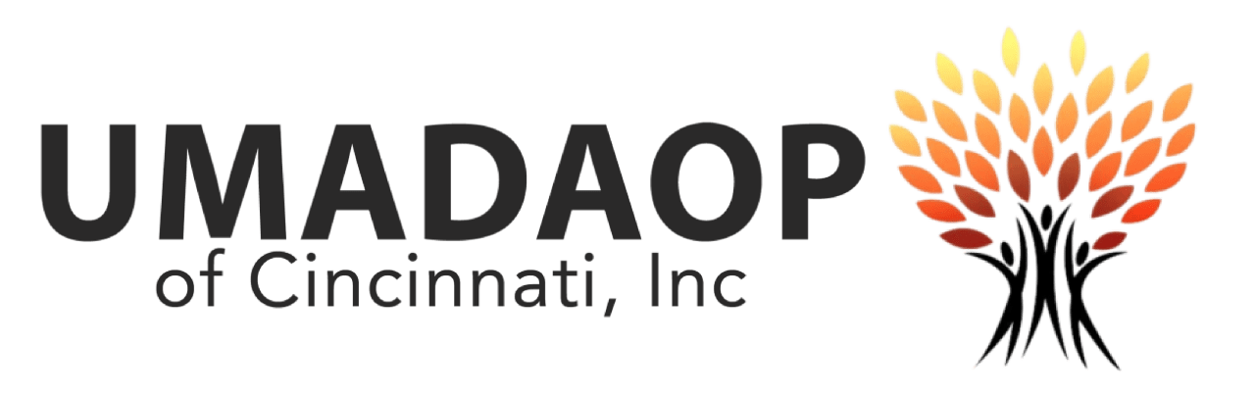
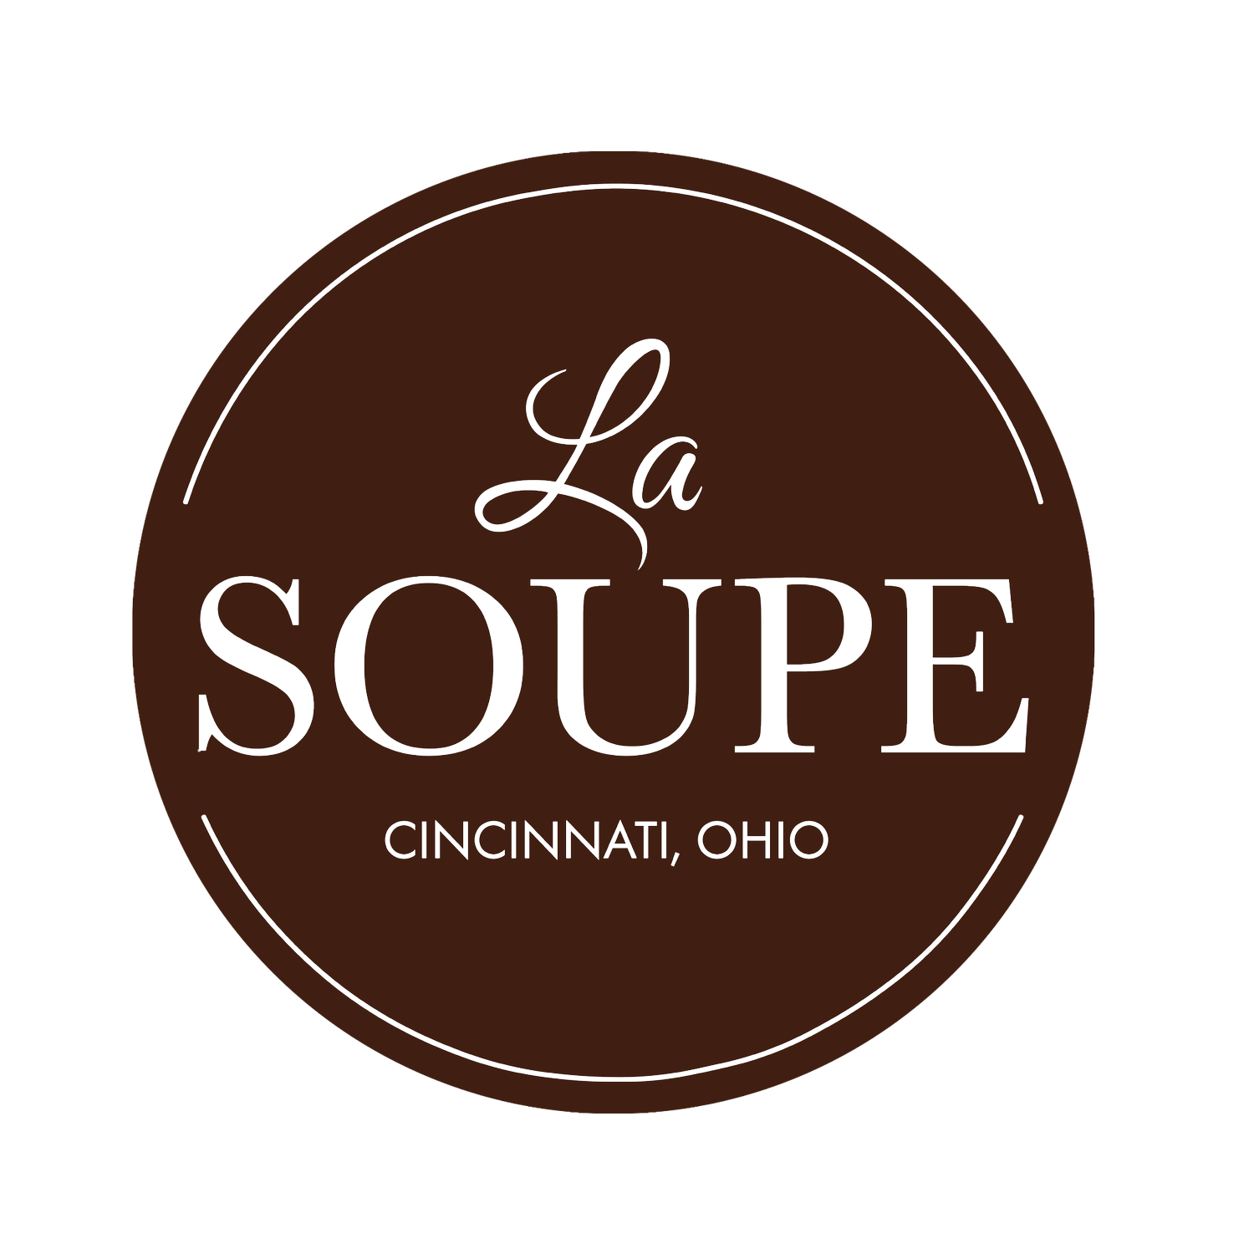



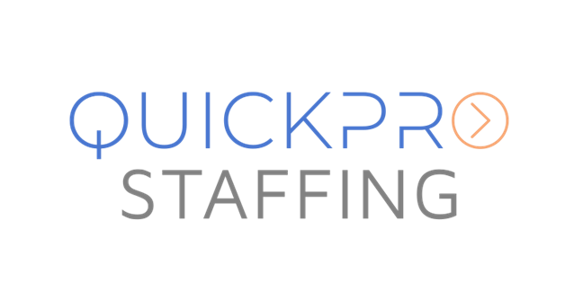
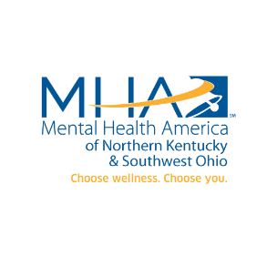

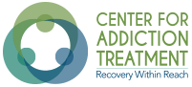


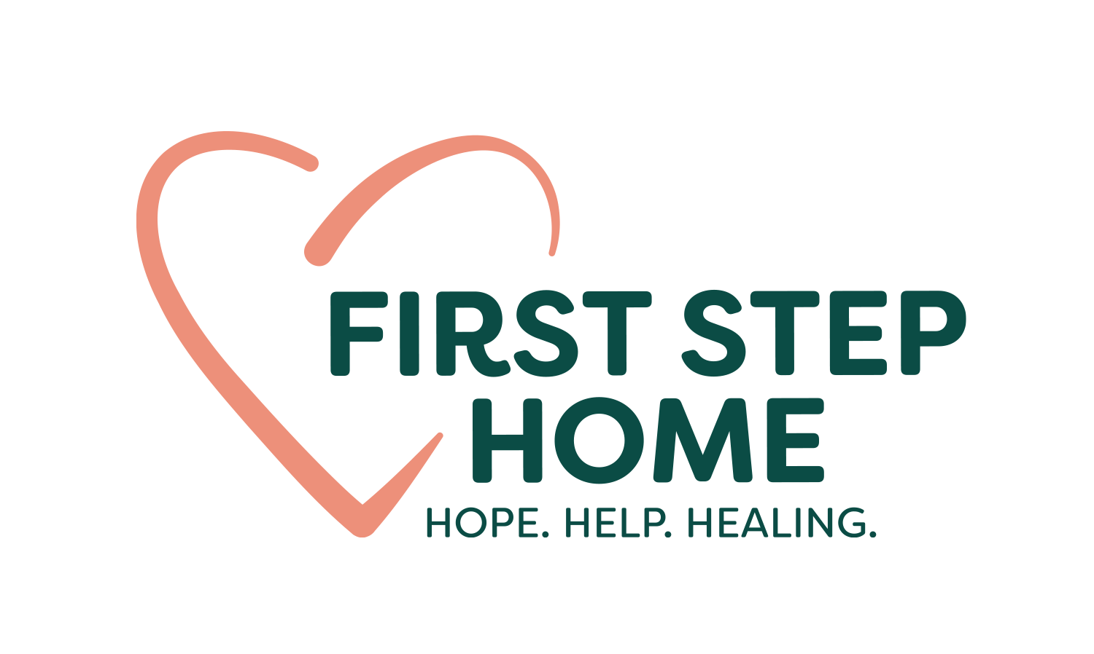




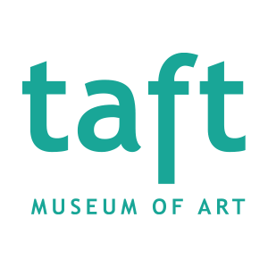


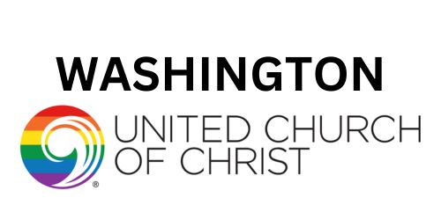
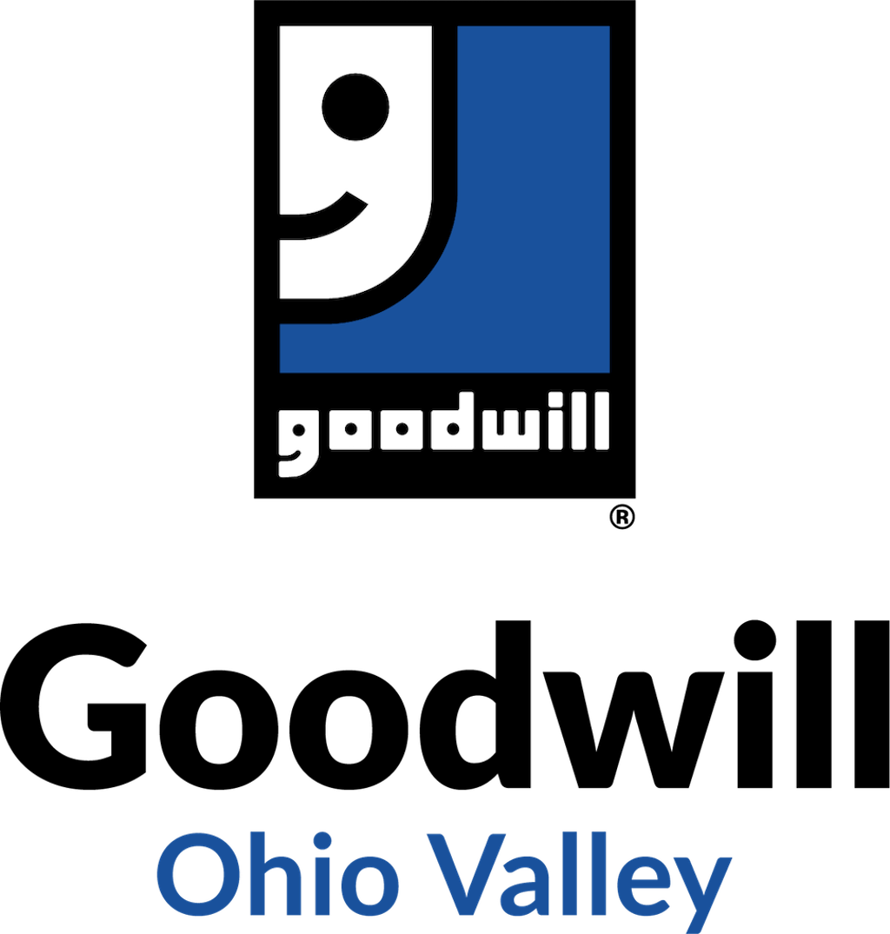
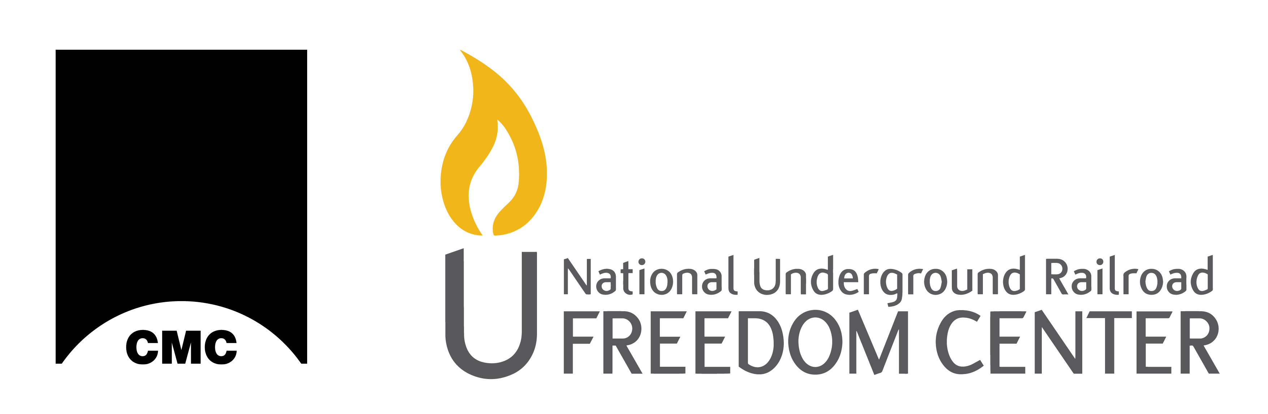
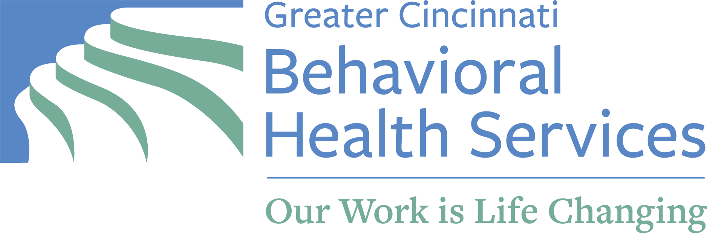
RFHC: A No-Cost Path to a Healthier Workforce
An initiative of Hamilton County Public Health, RFHC is a multi-award-winning, 100% free wellness and retention initiative that equips employers with resources to address SUD in the workplace while also supporting employees in recovery. With over 60% of individuals with SUD actively participating in the workforce, employers are already affected—often through lost productivity or increased turnover. The bottom line is being impacted! RFHC helps businesses respond by offering recruitment support, consultation, policy resources, training, overdose prevention tools like Narcan®, and more. Becoming a Recovery Friendly Employer is simple, responsible, and fiscally pragmatic. Joining involves a short orientation and a visible commitment to supportive practices. Join the growing number of workplaces investing in recovery—and benefiting from loyal, motivated, and resilient employees. Contact us today at tyler.meenach@hamiltoncountyohio.gov or 513-801-6205 to schedule a brief consult.
75+ Members and Growing!

